Springs

In this activity you will investigate the relationship between the stretching force on a steel spring and the extension it produces.

- You can stretch a spring by hanging a mass from it.
- Add a 100g mass to the spring and measure the extension it produces.

Remember:
100g = 1N on Earth
- Record your results in a spreadsheet
- Repeat this for masses up to 600g.
- For greater accuracy repeat the experiment once more times find the mean extension.

The extension of a spring tells us how much its length has increased from its original length. To measure extension you subtract the original (unloaded) length from the stretched length.
The extension is the extra length form the original position to the new stretched position – be careful NOT to measure the total length of the spring
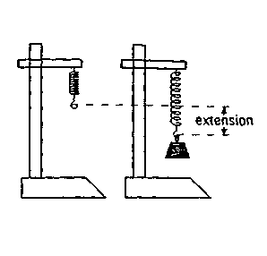Example table
This is the loaded reading - record this in your table and calculate the extension
This is the unloaded reading - record this above your table from the ruler

Unloaded reading on ruler / cm |  | 2.4
 | Loaded reading on ruler / cm
Force / N | 1st go | Check | Mean | Extension/cm
1 | 4.4 | 4.6 | 4.5 | 2.1
2 | 6.3 | 6.7 | 6.5 | 4.1

i.e when the force is 1 N the extension = 4.5 – 2.4 = 2.1 cm
when the force is 2 N the extension = 6.5 – 2.4 = 4.1 cm etc.
Graph
- Plot a graph of Force (Weight) against extension. Make sure you label your axes and give the correct unit.
- You should be able to draw a straight line of best fit through the points on the graph. The line of best fit is useful, as it smoothes out errors of measurement.
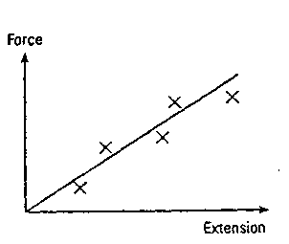

Conclusion: Use you graph to find:

- The relationship between Force and extension.
- The gradient (slope) of your graph. This is the spring constant in the equation below. Give the units of the spring constant.
Force = spring constant x extension F = kx

This equation is called Hooke’s Law. All springs obey this equation, they just have different spring constants.

Evaluation

- Were there any points that lie quite far from the line of best fit? We call these points anomalous results. You should circle these points on your graph.
- What sources of error might have caused some of your points to lie off your line of best fit?
- What changes could you make to your experiment to help improve the accuracy of your experiment?
Learning points:
Know that there is a relationship between the extension of a spring and the force applied to it.
Know how to calculate the gradient of a straight-line graph and appreciate its significance.
Improve your skills at writing a conclusion and evaluation.

